JULIE DAY
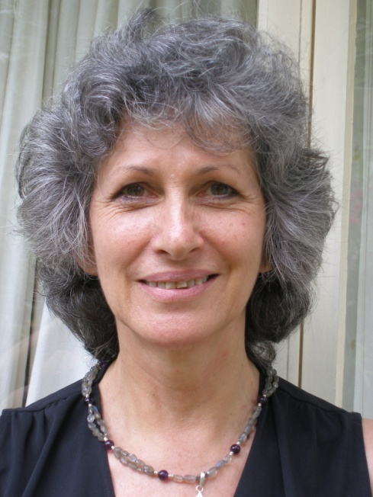
A Qualified Astrologer, member of the Federation of Australian Astrologers and the Association of Professional Astrologers I have built a strong clientele over the last 15 years in Brisbane and beyond.
During this time I set up the Centre for Spiritual Growth and began teaching classes from early to advanced levels taking students through these various stages to sit for the 4 examinations to qualify as an astrologer if you so chose.
I believe with support and encouragement we can understand ourselves so much better through the practice of astrology. We can change our perceptions, the way we direct our thoughts, opening our spirit to a more positive and purposeful energy. It is an exciting journey into mind, body and soul.
I have a holistic approach to astrology, exploring karmic issues and emotional blockages that lead to physical ailments. When we understand the problems we create and change our behaviour and the exchange of energy between others, then our life takes on a whole new meaning.
In my journey into the spiritual world I have taken many paths into healing modalities in order to improve my welfare and understanding. Each avenue afforded me more knowledge and awareness of the intrinsic connection that each and every person has with another.
We are all searching for peace and harmony, fulfilment, love and enjoyment. Finding the direction your spirit has chosen you to embrace this lifetime and how to fulfil your journey is so important to us all.
I give guidance in
- Development of personal strengths
- Career direction
- Behavioural problems
- Difficulties with children
- Relationship issues
- Timing of events
- Overview of the year at each birthday
I also hold monthly meetings in Voice Dialogue, a wonderful way of interacting with sub-personalities that are within us all and how they operate in our lives, bringing them to awareness and resolving issues.

Centre for Spiritual Growth
Please contact me on 3871 1162 for further information on courses and for personal and private consultations

