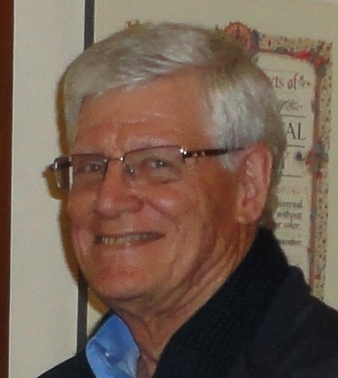
HARRIE BAHLIN

Harrie Bahlin BA, DipEd, DipLi and AdvDipEd has been studying astrology since October 1983 and teaching it since 1987. He has been President of the QFA and ACRUX editor, has served on the National FAA Council, edited the FAA Journal and was Treasurer for the FAA Conference in Brisbane in 1998.

Contact Harrie at harrie.bahlin41@gmail.com

