CHARYN McLEAN

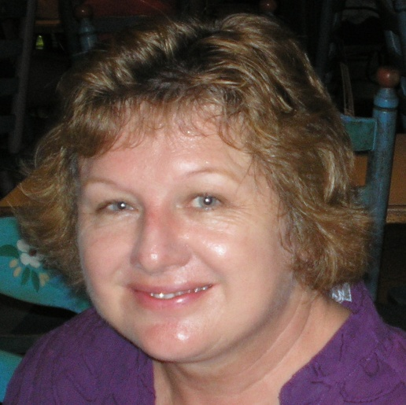

CHARYN McLEAN is a professional astrological consultant from Queensland holding a Dip Astro (FAA) and a Dip. Prof. Coun., she is also a teacher. Her astrological focus is psychological/karmic astrology.
Charyn approaches her work from a Chironic therapeutic perspective, integrating counselling and Australian bush flower essences with the art of astrology. She also works as a consultant for naturopaths and other alternative therapists who specialise in fertility issues.

Contact: charyn_m@yahoo.com.au
0413 044 025

