ALLISTAIR DUNCAN
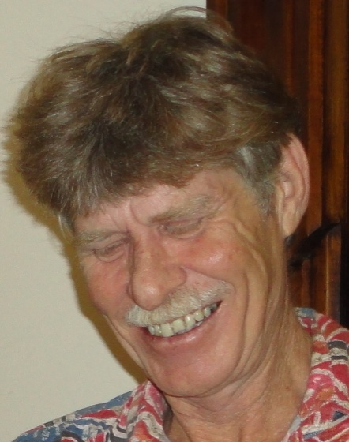
Allistair is a Qualified Astrologer, with a Dux Diploma for Best Thesis "What Makes an Astrologer". In addition to writing, and lecturing, Allistair operates a busy practise in Consulting and Tuition
Teaching for over 15 years, Allistair has ample consultative experience. He has been an active committee member, serving the QFA for a number of years. Allistair has written astrological articles for the QFA newsletter Acrux, the FAA Journal, and has published a 30 page booklet.
Allistair's preference is to teach students who have already mastered the basics and now want to evolve their interpretive skills via someone who has a lot of experience interpreting for the public.
Allistair's method of consultation is concern oriented, focusing on the issues at hand; problem resolution and self empowerment.
Contact Allistair at aldunc@qldnet.com.au or PO Box 703, Lismore 2480 NSW

